**Sindh:**

Mohenjo-Daro

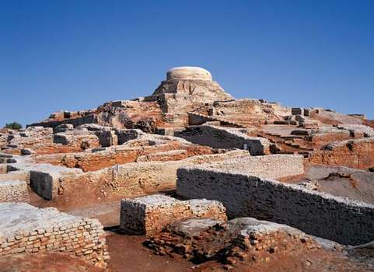

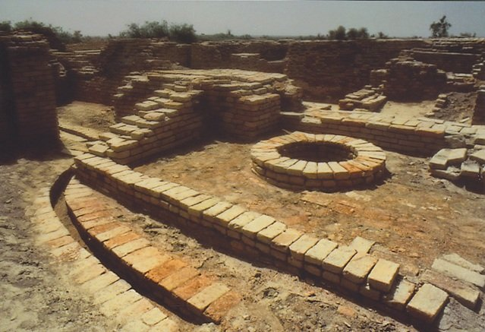

**Mohenjo-daro** Sindhi:meaning 'Mound of the Dead Men' is an archaeological site in the province of Sindh, Pakistan. Built around 2500 BCE, it was one of the largest settlements of the ancient Indus Valley civilization, and one of the world's earliest major cities, contemporaneous with the civilizations of ancient Egypt, Mesopotamia, Minoan Crete, and Norte Chico. Mohenjo-daro was abandoned in the 19th century BCE as the Indus Valley Civilization declined, and the site was not rediscovered until the 1920s. Significant excavation has since been conducted at the site of the city, which was designated a UNESCO World Heritage site in 1980. The site is currently threatened by erosion and improper restoration.

Mazar-e-Quaid

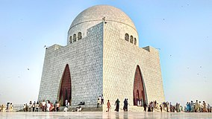

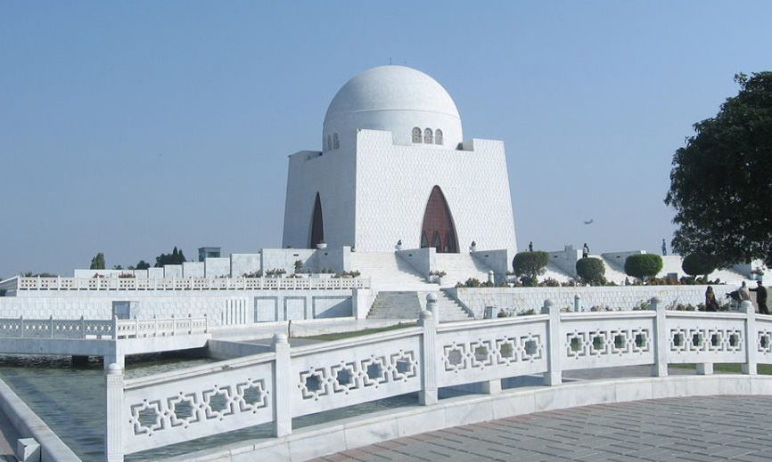

**Mazar-e-Quaid** also known as the **Jinnah Mausoleum** or the **National Mausoleum**, is the final resting place of Quaid-e-Azam ("Great Leader") Muhammad Ali Jinnah, the founder of Pakistan. Designed in a 1960s modernist style, the mausoleum also contains the tomb of his sister,Māder-e Millat ("Mother of the Nation") Fatima Jinnah, and that of Liaquat Ali Khan, the first Prime Minister of Pakistan.

Keenjhar Lake

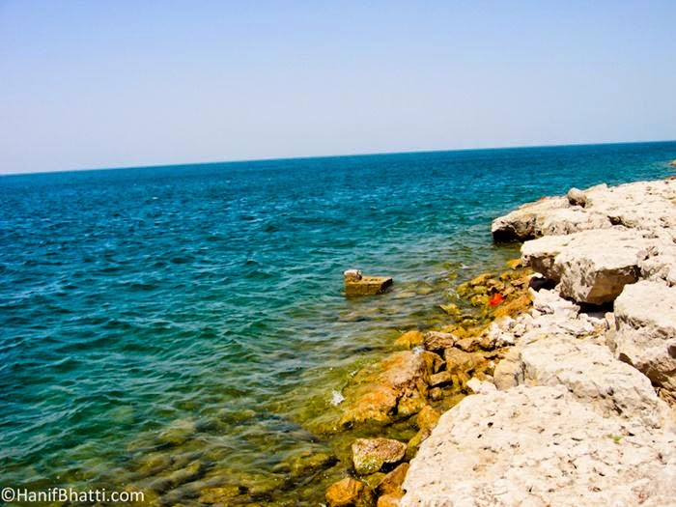

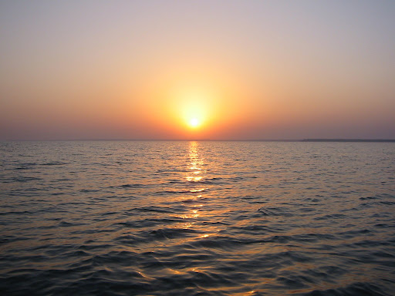

**Keenjhar Lake** is in Thatta District, Pakistan. It is 122km from Karachi and 18km from the town of Thatta. It is the second largest fresh water lake in Pakistan. It is an important source of drinking water for Thatta District and Karachi city. Keenjhar Lake has been declared a ramsar site and a wildlife sanctuary. It provides a favorable habitat of winter migratory birds like ducks, geese, flamingos, cormorants, waders, herons, egrets, ibises, terns, coots and gulls. It has been observed as a breeding area of the black-crowned night heron, the cotton pygmy goose, purple swamphen, and pheasant-tailed jacana.

Shah Jahan Mosque

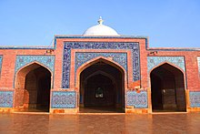

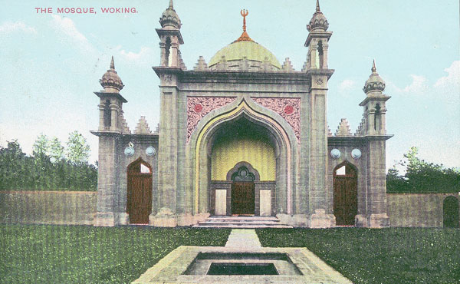

The **Shah Jahan Mosque** also known as the **Jamia Masjid of Thatta** , is a 17th-century building that serves as the central mosque for the city of Thatta, in the Pakistani province of Sindh. The mosque is considered to have the most elaborate display of tile work in South Asia, and is also notable for its geometric brick work - a decorative element that is unusual for Mughal-period mosques. It was built during the reign of Mughal emperor Shah Jahan, who bestowed it to the city as a token of gratitude, and is heavily influenced by Central Asian architecture - a reflection of Shah Jahan's campaigns near Samarkand shortly before the mosque was designed.

Sandspit Beach

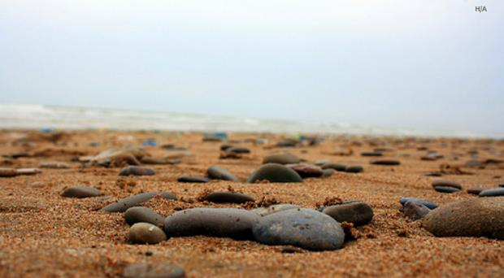

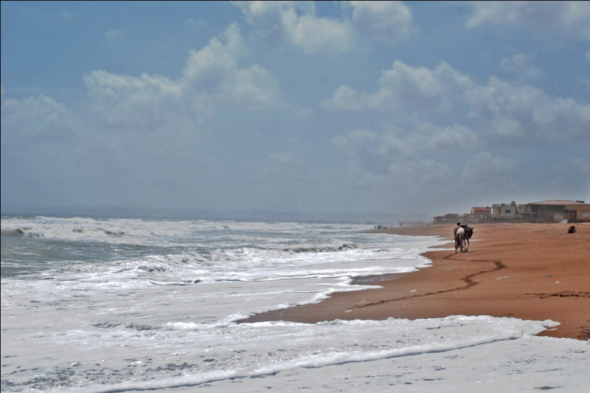

The Sandspit Beach is also a nesting ground for Green and Olive Ridley Turtles, implemented by the Sindh Wildlife Department over the past two decades. Nesting takes place in early winter months. In recent years the WWF-Pakistan has also become involved in turtle conservation activities by establishing a Wetland Centre at the Sandspit beach.

Kirthar Mountains

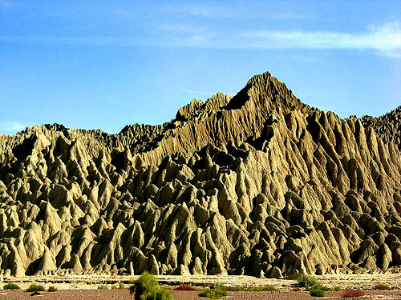

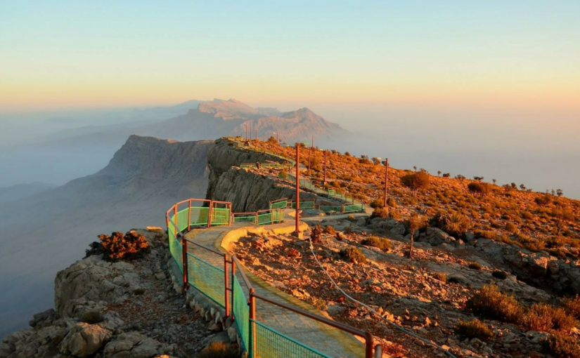

The **Kirthar Mountains** are a mountain range located in the Pakistani provinces of Balochistan and Sindh. The mountains extend southward for about 190mi (310km) from the Mula River in east-central Balochistan to Cape Monze on the Arabian Sea. The Kirthar Mountains form the boundary between the lower Indus Plain (to the east) and southern Balochistan (to the west). It consists of a series of parallel rock hill ridges rising from 4,000ft (1,200m) in the south to nearly 8,000ft (2,400m) in the north.